TASK Technology Process

Task Using Inspiration create a diagram that covers the Technology Process for ICT

See below = Technology Process Chart for information required.
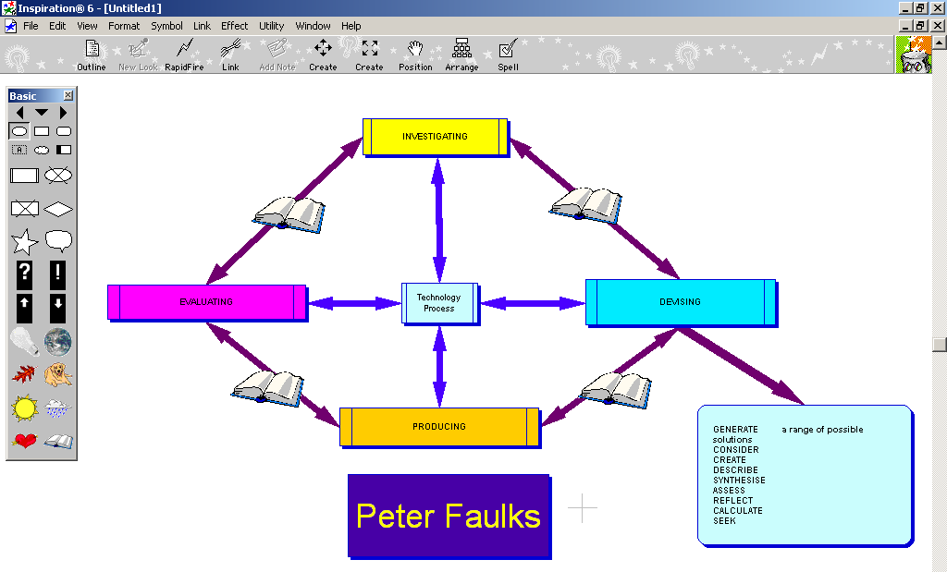

Or use Graphic boxes in Power Point to create an image of the Technology Process

TECHNOLOGY PROCESS
Levels | Investigating | Devising | Producing | Evaluating
4 | Examines the values and beliefs of both the developer and user that are evident in technology. | Generates designs that take into account social and environmental values and communicates using a range of graphical representations, models and technical terms. | Organises and implements own production processes working within given constraints, recognising hazards and adopting safe work practices. | Assesses how well the ideas, products, systems, processes, services and environments used meet design requirements, including consideration of social and environmental effects.
5 | Determines the appropriateness of technologies for communities and environments. | Creates and prepares design proposals that include options considered and reasons for choices made, and uses images to visualise ideas and work out how designs might be realised. | Organises and implements production processes to own specifications, recognising hazards and adopting safe work practices. | Assesses the effectiveness of own designs, products, systems, processes, services and environments in relation to design requirements, including consideration of social and environmental criteria.
6 | Investigates and explains how the design, production and use of technologies are affected by the needs of individuals, communities and environments. | Creates and prepares design and production proposals that include an examination of a range of options; demonstrates consideration of functional, aesthetic, social and environmental issues; and communicates using graphics and technical languages associated with particular fields of technology. | Organises, implements and adjusts production processes based on detailed production plans, which are described using suitable technical languages and conventions and which achieve defined standards of quality and safety. | Assesses own products, systems, processes, services and environments according to specified design requirements, including ethical criteria and comparisons with similar technologies.

What is the technology process?
The technology process is a range of strategies that you use to develop your thinking skills. It’s thinking about the way that you think. Thinking skills include the way that you dream up ideas and concepts, how you create and make things. It can also include ways that you discover information, solve problems and evaluate solutions.
The technology process has four main steps, which are interlinked.

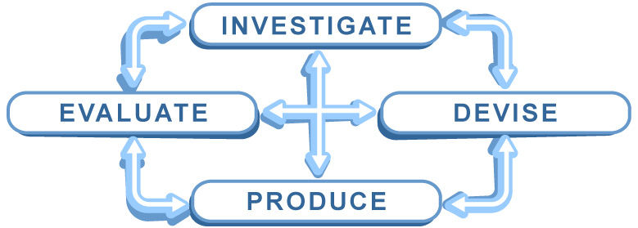

When you apply the process, you might start at any one of the four aspects and jump between them. There is no set order in which to work.
For example if you wanted to redesign an existing product for a new market, you might begin with an Evaluation of the existing product.
If you needed help planning your work, then you might start with an Investigation and move to Devising to plan your time and bring your ideas to life.

Why use the technology process?
The technology process can help you develop techniques to improve the way you think and work. This can be achieved by completing some specialised activities.

For example, if you can’t think of new ideas, you could use a technique called brainstorming. Once you have some ideas, you may not know where to begin working out what to do with them. In this case, a plan can be developed using a storyboard.

A brainstorm and a storyboard are tools, which help you express how you think.
It is not always obvious to your teachers or classmates how you have generated your ideas, what path you intend to follow or how you decided what was good work and what was bad. Using the thinking tools as part of the technology process is the easiest way to demonstrate your thinking. Including your tools in your Portfolio helps your teacher to assess your progress.

Where to begin?
To successfully complete any of your activities or tasks and to use your time effectively, you need to ensure that you fully understand what you are required to do. You should always ask yourself:

What do I have to do?

If you can explain in your own words what needs to be done, you will demonstrate that you have a good understanding of the activity or task.

Technology Process Explained

“INVESTIGATION”

Investigate
Students explore the form of products and their everyday use by giving sensory focus to their investigation: for example, they touch or rotate objects to help observe the features of an object and they move or rotate objects and equipment to explore their uses. They attend and respond to materials, resources and processes from their everyday experiences: for example, they may show curiosity toward new resources or anticipate the outcome of a cooking process. Through imitating others or by trial and error, they use products for their intended purpose, such as using a wooden spoon to stir a mixture or glue to connect paper. They also improvise and use familiar products in creative ways, such as plastic cups to build a structure or a pencil as a rolling pin. Through exploring and using products they may develop the basic skills to cut, paste, attach, roll, press or pinch.

Is finding information, identifying opportunities and considering implications of creating products

ANALYSE the set criteria of the Design Brief
EXPLORE the options allowed by the Design Brief
DEFINE a focus for your investigation
SEARCH databases for ideas (eg: Internet, books, etc)
REVIEW “historical” data; learn from trials of others
REALITY CHECK – equipment, materials, timeframe
DETERMINE constraints and limitations
IMAGINE creative alternatives
DEVELOP a profile of the audience/client
ASSESS the potential impact to society

“PRODUCING”

Produce
Students participate in production processes: for example, they may indicate a picture of interest in a magazine and help to tear out or cut and glue the picture to a birthday card they make for a friend. They follow procedures and step-by-step instructions and use tools for their intended purpose: for example, they press a switch to turn on a microwave oven, press on keys to enter information into a computer, or use sand paper to sand a wooden item. They begin to organise their own actions into a process by following pictures or visual cues: for example, they sequence a set of photographs of popcorn being prepared, or a wooden toy being made, and are able to follow the sequence to repeat the activity with support.

Is organising and managing the creation of creation of your design solution in a work environment

ORGANISE a system to achieve goals
NEGOTIATE use of shared equipment
AQUIRE new skills if you need them
SELECT the “tools” for optimum results
APPLY your skills to the best of your ability – aim high!
ADAPT & ADJUST to unexpected problems
COMMUNICATE clearly to collaborate effectively
MENTOR/ASSIST if peers need a little help
REFLECT on your progress every session – “Journal”
RESPECT safety procedures at all times

“DEVISING”

Devise
Students indicate their ideas, such as choosing from a given selection when developing a solution for creating a technology: for example, when generating ideas for a snack, they select bread to put in a toaster and choose a knife instead of a fork to spread the topping. They use vocalisations or gestures to select from options provided: for example, they point, nod, speak, pick up or use facial expressions to accept or reject items. When asked or prompted, they indicate their preferred method for an activity or material, appropriate item or action for a specific purpose.

Is the process of generating ideas and creating plans and proposals for solving design issues?

GENERATE a range of possible solutions
CONSIDER your client/audience/market and their needs
CREATE a written proposal, clarifying your intention
DESCRIBE the materials, tools, equipment, you will need
SYNTHESISE plans, sketches, storyboards, technical drawings, recipes, patterns, layouts, and electronic drafts
ASSESS how they address Design Brief specifications
REFLECT on the skills you will need
CALCULATE expected costs & quantities
SEEK group members with necessary skills

Evaluate
Students express feelings about the processes they used and the product they have made: for example, they use structured choice-making to show the objects they liked to use and point to pictographs or photographs of the activity they did or did not like; communicate through vocalisations or gestures their feelings about the toast they made and ate, or a birthday card they created to give to a friend. They communicate their responses to an experience in individual ways, such as using vocalisations or gestures to request repetition of particular parts of the process. They express their emotions and judgements about the product: for example, they point to a picture of a smiling face or do not eat the food they cooked. They begin to answer questions about the features of a finished product: for example, they nod when asked if their card is a certain colour or verbalise the name of the material used to make a model.

